Product Requirements Document: RACKAI Monitoring

Table of Contents
1. Vision 4
2. Problem Statement 4
3. Product Principles 5
4. Scope 5
In Scope 5
Out of Scope 5
5. Core Entities 6
System Metric 6
Alert 6
Incident 6
Service 6
Kubernetes Resource 7
Infrastructure Resource 7
6. Monitoring Model 7
Cluster-Level 7
Node-Level 7
Pod-Level 7
Workload-Level 7
Control Plane 7
7. Metrics Categories 8
Infrastructure Metrics 8
GPU Metrics (Critical) 8
Service Metrics 8
Workload Metrics 8
8. Monitoring Data Flow 8
Sources 9
9. Kubernetes Event Integration 9
Requirements 10
10. Alerting & Incident Detection 10
Alert Types 10
Examples 10
Requirements 10
11. Incident Management 10
Lifecycle 10
Incident Data 11
12. Scaling & Automation 11
Kubernetes Auto-Scaling 11
Scaling Signals 11
13. Integration with Platform Systems 12
Principles 12
Scope of Integration 13
Outcome 13
14. API & Access 13
Access Control 13
15. Failure Handling 13
16. Success Criteria 13
17. Summary 14
Final Statement 14
What this enables 14
Outcome 14
Conclusion 15

Document Name | RACKAI Monitoring
Version | v1.0
Status | Review
Author | Amine Badaoui
Date Created | 30/04/2026
Last Updated | 30/04/2026
Stakeholders | Product, Engineering
Reviewers

1. Vision
Provide a real-time, reliable, and scalable monitoring system that enables platform operators to understand, maintain, and optimize the health and performance of the RACKAI platform.
The system must ensure that:
- platform services remain available and performant
- issues are detected and diagnosed quickly
- infrastructure scales efficiently with demand

The system should make platform monitoring feel:
- proactive — issues are detected before users are impacted
- reliable — monitoring data is accurate and timely
- actionable — signals lead directly to decisions
- scalable — supports growth in tenants, workloads, and infrastructure

2. Problem Statement
As RACKAI scales across:
- tenants
- inference and fine-tuning workloads
- GPU-intensive infrastructure
- Kubernetes clusters
system complexity increases significantly.
Without platform monitoring:
- failures go undetected or are detected too late
- latency and performance degrade unpredictably
- GPU resources are inefficiently utilized
- incidents are difficult to debug
- scaling decisions are reactive

Impact
- reduced system reliability
- increased downtime and MTTR
- inefficient infrastructure usage
- degraded user experience

3. Product Principles
- System Health First
Monitoring prioritizes platform reliability and uptime
- Real-Time Awareness
Critical signals must be available with minimal latency
- Actionable Signals
Metrics must drive alerts, scaling, and remediation
- Kubernetes-Native Design
Monitoring aligns with pods, nodes, and clusters
- Separation from Tenant Observability
Monitoring is for operators, not end users

4. Scope

In Scope
- Kubernetes cluster monitoring
- infrastructure monitoring (CPU, GPU, storage, networking)
- platform service monitoring
- workload execution monitoring
- alerting and incident detection
- system-level dashboards

Out of Scope
- tenant dashboards (covered in observability PRD)
- audit logging (covered in audit PRD)

5. Core Entities
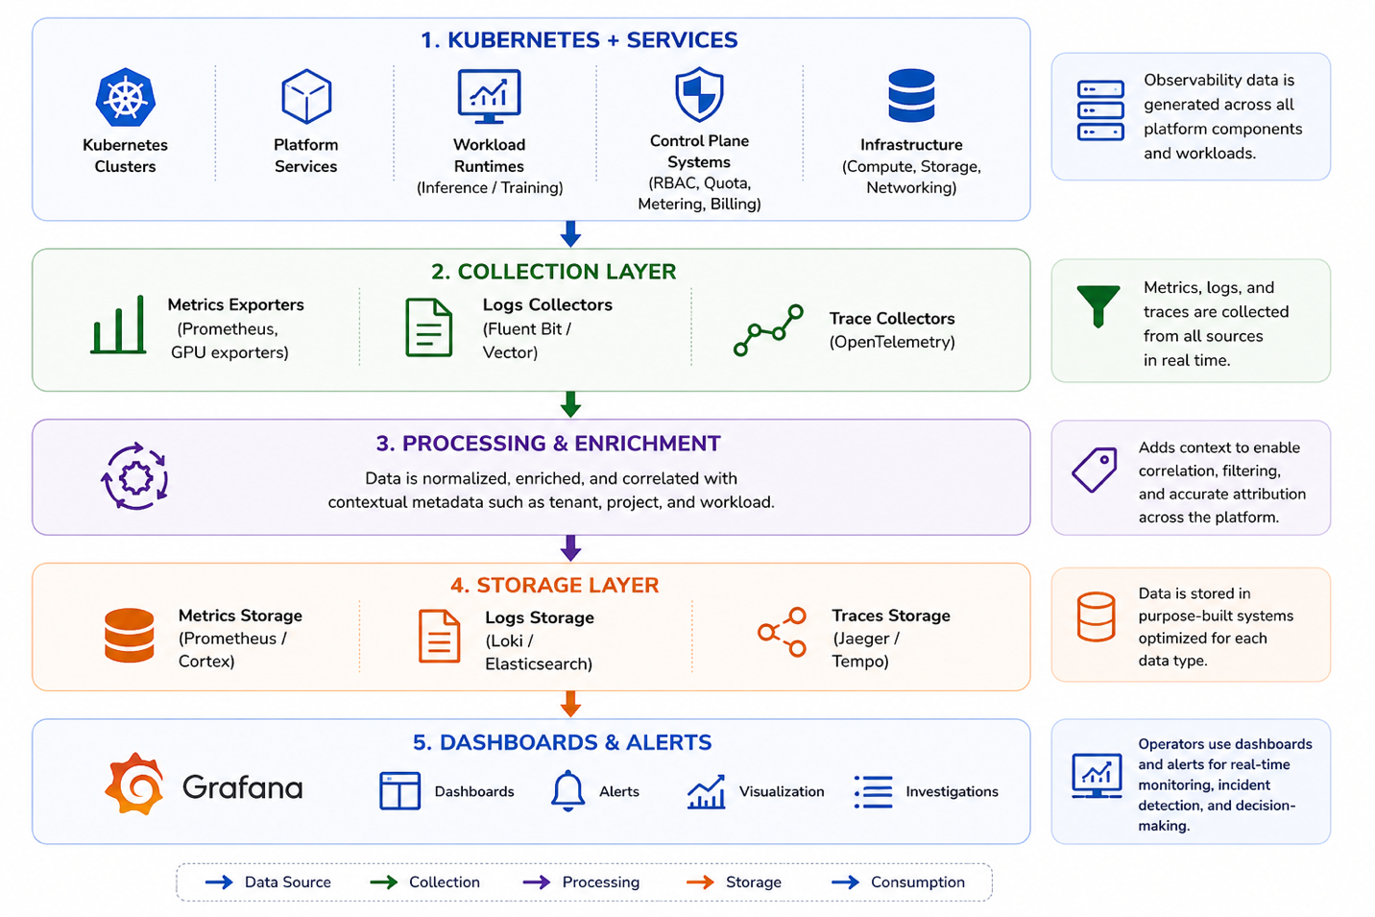

System Metric
- time-series representation of system state

Alert
- triggered condition based on thresholds

Incident
- system issue requiring investigation

Service
- platform component (inference, RBAC, quota, etc.)

Kubernetes Resource
- pods, nodes, deployments, jobs

Infrastructure Resource
- CPU, GPU, memory, storage, networking

6. Monitoring Model

Cluster-Level
- API server health
- scheduler performance
- cluster availability

Node-Level
- CPU / memory usage
- GPU utilization
- node readiness
- disk and network performance

Pod-Level
- pod lifecycle (pending, running, failed)
- restarts and crashes
- resource usage

Workload-Level
- inference latency
- fine-tuning job duration
- throughput and error rates

Control Plane
- RBAC latency
- quota enforcement latency
- metering pipeline lag
- billing system health

7. Metrics Categories

Infrastructure Metrics
- CPU utilization
- memory usage
- Storage I/O
- network throughput

GPU Metrics (Critical)
- GPU utilization (%)
- VRAM usage
- GPU allocation per workload
- scheduling and queue delays

Service Metrics
- request latency
- throughput
- error rate

Workload Metrics
- execution duration
- success/failure rates
- resource consumption

8. Monitoring Data Flow

Observability data is generated across Kubernetes workloads and platform services, and is collected through metrics exporters, log collectors, and trace collectors.
This data is enriched with tenant, project, and workload context, then processed and stored in dedicated systems for metrics, logs, and traces.
The resulting data is made available through dashboards and alerting systems, enabling real-time monitoring, troubleshooting, and operational decision-making across the platform.


Sources
- APIs and microservices
- workload runtimes
- Kubernetes infrastructure
- control plane systems

9. Kubernetes Event Integration
Kubernetes events are a key source of truth for diagnosing scheduling issues, failures, and resource constraints.
The monitoring system must ingest and correlate these events to enable rapid detection and troubleshooting of platform issues.
The system must ingest Kubernetes events:
- pod scheduling failures
- container restarts
- node failures
- resource exhaustion

Requirements
- events must be correlated with workloads
- visible in dashboards
- linked to traces and logs

10. Alerting & Incident Detection
The platform must support real-time alerting to detect failures, anomalies, and performance degradation.
Alerts translate monitoring signals into actionable notifications, enabling rapid detection and response to system issues.

Alert Types
- threshold-based alerts
- system failure alerts
- resource saturation alerts

Examples
- latency > threshold
- GPU utilization saturation
- service unavailable
- error rate spike

Requirements
- alerts must be real-time
- configurable
- scoped to system or service

11. Incident Management

Lifecycle
Incident handling must follow a consistent lifecycle to ensure rapid detection, effective investigation, and timely resolution of system issues, minimizing impact to tenants and workloads
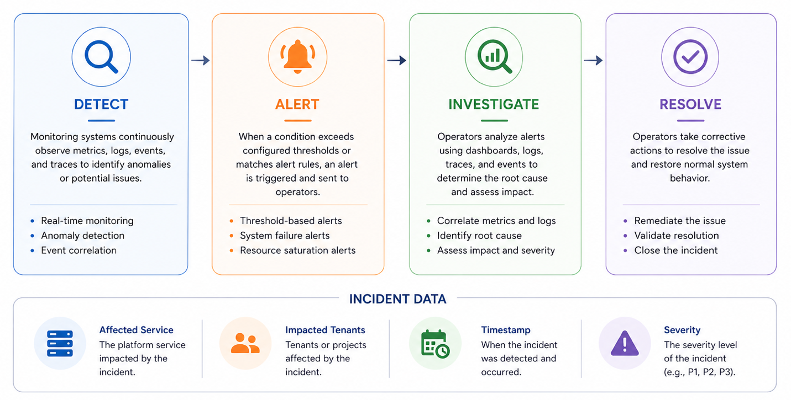

Incident Data
- affected service
- impacted tenants
- timestamp
- severity

12. Scaling & Automation
Monitoring data must be used to drive dynamic scaling decisions, enabling the platform to automatically adjust resources in response to workload demand and system performance.

Kubernetes Auto-Scaling
Monitoring must integrate with:
- Horizontal Pod Autoscaler (HPA)
- Cluster Autoscaler
- GPU scheduling systems

Scaling Signals
- request rate
- latency
- GPU utilization
- queue depth
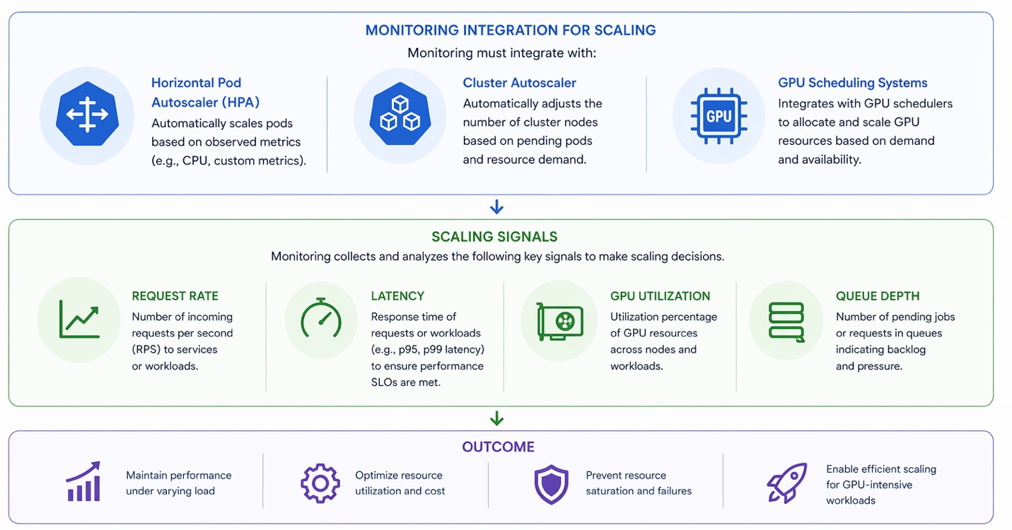

13. Integration with Platform Systems
Monitoring integrates with:
- inference services
- fine-tuning services
- RBAC system
- quota system
- metering system
- billing system
The platform must leverage existing Rackspace monitoring and observability capabilities wherever possible, rather than building new monitoring systems from scratch.

Principles
- reuse existing Rackspace monitoring infrastructure
- integrate with existing metrics, logging, and alerting pipelines
- avoid duplication of monitoring capabilities
- align with Rackspace operational standards

Scope of Integration
The system should integrate with:
- existing metrics collection platforms
- log aggregation and storage systems
- alerting and incident management tooling
- monitoring dashboards and visualization platforms

Outcome
This ensures:
- faster implementation and reduced time to value
- lower operational overhead
- consistency across Rackspace platforms
- alignment with enterprise-grade monitoring practices

14. API & Access
Monitoring data must be accessible via:
- internal APIs
- operator dashboards

Access Control
- restricted to platform operators
- not exposed to tenants

15. Failure Handling
- monitoring failures must not impact workloads
- missing metrics must be detectable
- alerting must fail safely (no silent failures)

16. Success Criteria
- real-time system visibility
- reduced incident detection time
- reduced incident resolution time
- efficient resource utilization
- reliable auto-scaling decisions

17. Summary
Platform monitoring provides the system health and reliability layer for RACKAI.
It ensures that:
- system behavior is continuously visible
- issues are detected early
- infrastructure is efficiently utilized

Final Statement
Platform monitoring ensures that the platform itself is continuously observable, reliable, and scalable, providing real-time insight into system health, performance, and resource utilization across all components.
By leveraging Kubernetes-native monitoring and integrated observability pipelines, the system enables:
- continuous visibility into system behavior across clusters, nodes, and workloads
- early detection of failures and performance degradation before they impact tenants
- efficient resource utilization and scaling, particularly for GPU-intensive workloads
- rapid incident response and root cause analysis through correlated metrics, logs, and events

What this enables
Platform monitoring allows RACKAI to:
- maintain high levels of availability and performance across all tenants
- ensure predictable and stable system behavior under varying load conditions
- support automated scaling and capacity planning based on real-time signals
- provide operators with the tools needed to operate, troubleshoot, and optimize the platform at scale

Outcome
Every aspect of the platform—from infrastructure to workloads—is:
- visible through real-time monitoring
- measurable through system and workload metrics
- actionable through alerts and automation
- reliable through continuous health validation

Conclusion
Platform monitoring enables RACKAI to operate as a:
high-availability, resilient, and Kubernetes-native AI platform—where system health, performance, and scalability are continuously managed, validated, and optimized.

